Membership Registration for Institutional Members

Name of institution

Name of contact person

Statement of contact person to be entitled to represent the institution vis-à-vis the ITD- Alliance

Short description of the institutions’ focus and strategy related to collaborative modes of research and education (text field can be expanded)

Motivation to become a member of ITD-Alliance (text field can be expanded)

Main expectations of what should be achieved with/through the Alliance (text field can be expanded)

Membership scheme

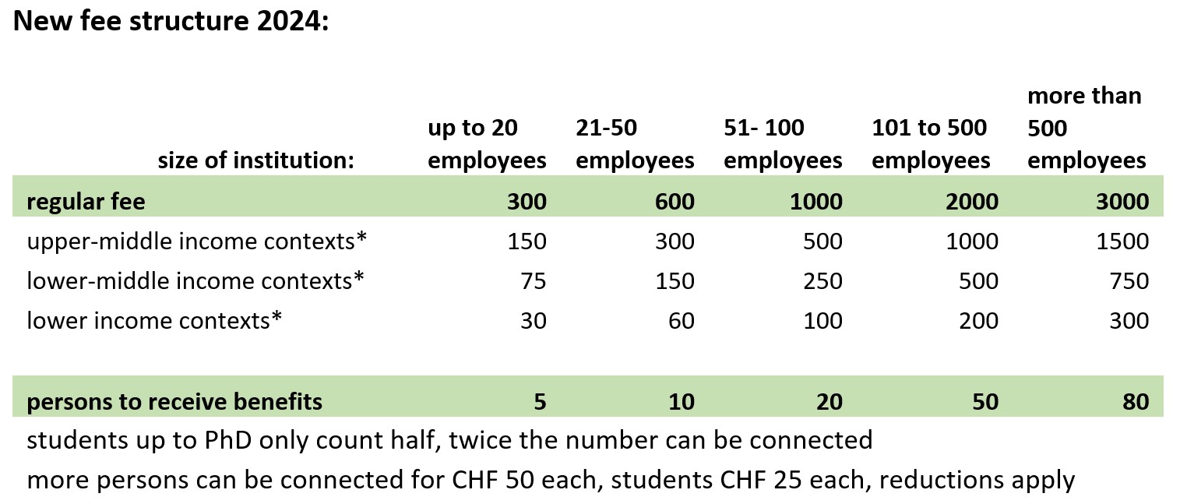

Your fee category (Do not hesitate to contact us to find your suitable category):

Membership procedure for Institutional Members
After having received your application, the ITD Alliance Leadership Board will decide on your membership and, if requested, if a fee reduction is applicable. If assessed positively by the board, an invoice will be transmitted and the institution will be listed on the public list of members on the website (website soon to go public). Your membership will be installed after the payment of the membership fee.

Membership benefits include:
- being part of a dynamically growing community of experts and leading institutions in inter- and transdisciplinarity,
- receiving reduced conference fees for the ITD conferences (for up to 5 participants),
- participation in working groups for all members of the institution,
- being visible on the ITD Alliance webpage,
- receiving a membership button for your webpage,
- several members of your institution can receive access to the membership space on the ITD Alliance website
- electing the members of the leadership board

Looking forward to welcome your institution as member of the ITD Alliance.

For any questions, do not hesitate to contact Tobias Buser, Executive Secretary of the ITD Alliance: tobias.buser@itd-alliance.org

