Train-the-TD-Trainer Session
SRI - Panama

Invitation: Are you interested in developing your skills as a transdisciplinary research trainer?
If you are, and you are also:
• Familiar with the basics of transdisciplinary research either as the lead or key participant in several projects; or
• A "boundary spanner", someone who has worked with academic researchers and societal actors on sustainability projects; or
• A faculty member who has taught courses on transdisciplinary research,
this training event is for you!

We will select no more than 15 participants for this in-person train-the-trainer experience.

Note: This is not a transdisciplinary research training (TD) but rather a how-to session for those familiar with TD, who would like to help train others in TD skills. Doing so helps expand the number of scholars who work in this way. As such it will help normalize TD practice, expand the network of TD researchers and trainers, and further build the TD field.

Requirements:
All participants must be registered for the SRI conference in Panama. If you are unable to pay the registration fee, scholarships are available for a limited number of participants.

Please complete this short application (questions below) by March 17, 2023 and send your responses to Margaret Krebs (mkrebs@stanford.edu).

Training date: June 28, 2023 at SRI in Panama
The workshop will be a full day and in person only. Lunch will be provided for all participants.

During the workshop you will practice using a structured approach that will help you make choices for designing a TD training for an audience of your choice. You will learn how to develop an effective training and get feedback on:
• Workshop flow: Sequencing of the learning activities;
• Workshop aids: Tools and resources that match your learning goals; and
• Workshop contents: Integration of content knowledge, competencies, and mindsets

Training benefits to participants
• Design skills needed to develop trainings for TD researchers;
• Specific resources and tools that have been tested by experienced trainers;
• A cohort of colleagues with whom to exchange ideas after the workshop; and
• Readiness for and opportunities to facilitate workshops and trainings

Training facilitators
Facilitators (bios below) are members of the Transdisciplinary Training Collaboratory: Building Common Ground, a project supported by a US National Science Foundation grant. The project brings together pioneering researchers and trainers from regional centers across the globe who have been working within their regions to:

1) Synthesize existing knowledge on the key concepts, competencies, common language, and accepted phases of different types of transdisciplinary research; and
2) Create a design guide for trainers, accompanied by resources cataloged by the
framework developed from the synthesis work.
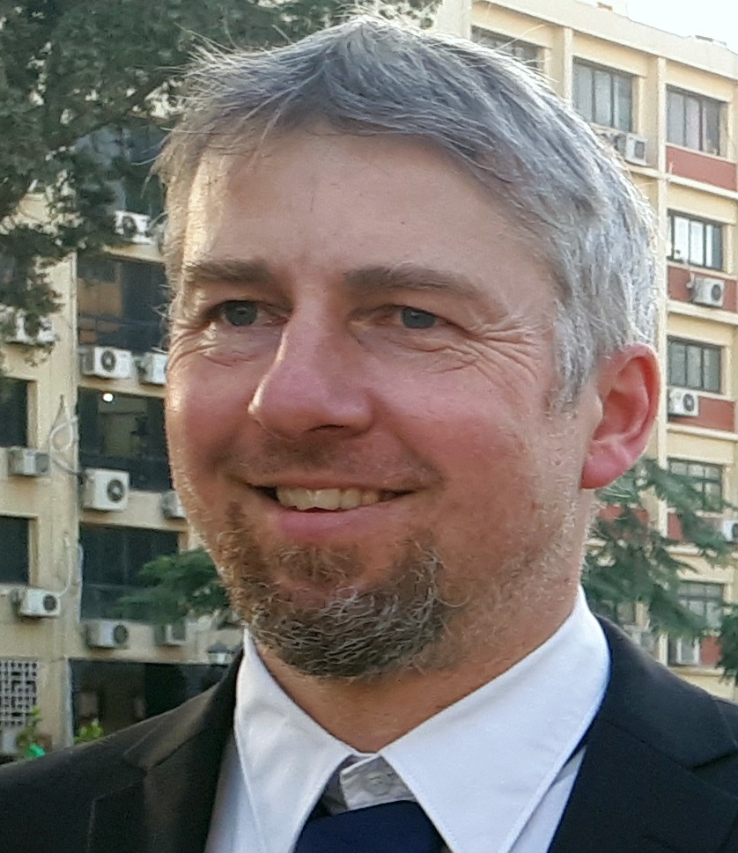
Tobias Buser, Executive Secretary, ITD Alliance
Tobias is an expert in collaborative research processes, with profound experience in designing, conducting and reflecting transdisciplinary research processes. He is deeply engaged in training, coaching and consultancy for transdisciplinary research, e.g. with the first massive open online course on transdisciplinarity, with training for programmes of the International Science Council, the Network of African Science Academies, UNESCO, Future Earth, and several universities. As Executive Secretary of the Global Alliance for Inter- and Transdisciplinarity, he is enthusiastic about building capacities and supporting international collaboration to advance and foster research approaches and institutional conditions that enable to address pressing sustainability challenges.

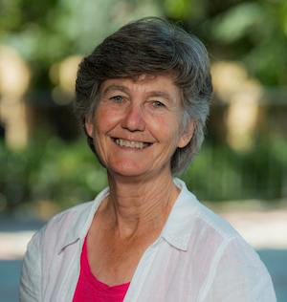
Margaret Krebs, Project Director, Transdisciplinary Training Collaboratory
Margaret's focus for the last ten years centers around defining key leadership skills and approaches for academic researchers who aim to further "knowledge to action" as the Program Designer for the Earth Leadership Program. She also offers workshops to graduate students and postdocs on interdisciplinary collaboration through university leadership programs at University of British Columbia, McGill, Cornell, and Stanford.

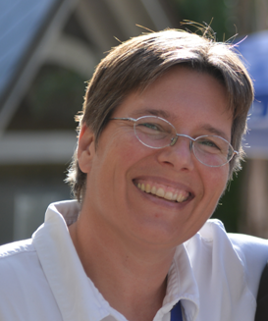
Susanne Moser, Lead Facilitator, Transdisciplinary Training Collaboratory
Susi Moser (she/her) is an independent scholar and consultant who works in the US and internationally from a base in western Massachusetts/USA, the unceded ancestral homeland of the Nipmuc and Pocumtuc. A geographer by training (Ph.D. 1997, Clark University), her work over the past 30 years has focused on adaptation to climate change, climate change communication, science-policy interactions, and psycho-social resilience in the face of the traumatic and transformative challenges associated with climate change. She has served on scientific advisory boards for Future Earth, the International Science Council, the US National Research Council and contributed to IPCC and US national climate assessments. You can learn more about her work at https://www.susannemoser.com.

Application Questions:

- Tell us about your experience leading or participating in transdisciplinary research projects. (Please include what sustainability issues you work on, who is involved in these projects, where you work (if applicable), your role in these projects and any other relevant information.)

- Have you facilitated or led any kinds of workshops? Do you have teaching experience? (Please be specific regarding audience, length/type of workshops and training or teaching.)

- If you have led a TD training workshop, what did you find challenging? What would you hope to learn from our workshop in Panama?

- What TD training opportunities might you have in the next year or more? (Please be specific about the likely audience, level of experience of participants, contexts in which trainees might use TD skills etc.)

- Envision yourself as having become an excellent TD trainer. What would that look like?

